Velammal Institute of Technology
Department of AI&DS
Report:PowerBI Workshop

A comprehensive workshop on **PowerBI** was organized on 19/09/2025 and 20/09/2025 for 3rd year AI&DS-A section and 26/09/2025 and 27/09/2025 for 3rd year AI&DS-B section students with the objective of introducing them to the basics of relational databases and database management systems. PowerBI, a powerful open-source object-relational database system, is known for its robustness, performance, and support for advanced data types. The goal of the workshop was to equip students with both theoretical knowledge and practical skills that are applicable in academic and industry settings.
The workshop began with a brief introduction to databases, Introduce participants to Power BI fundamentals. Demonstrate data connection, cleaning, and modeling techniques. Teach visualization creation and dashboard publishing. Enable participants to analyze and share business insights effectively.
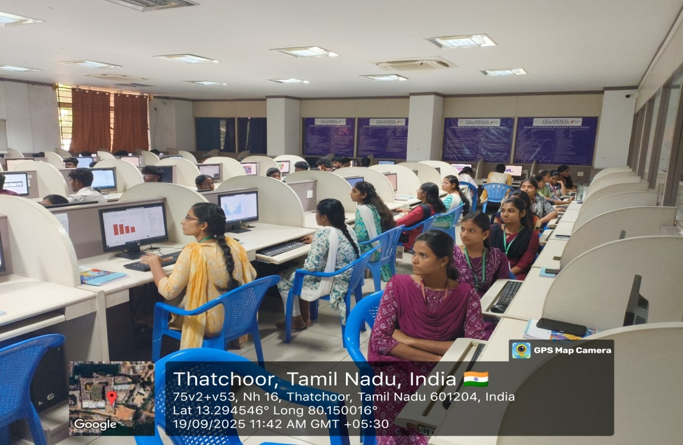
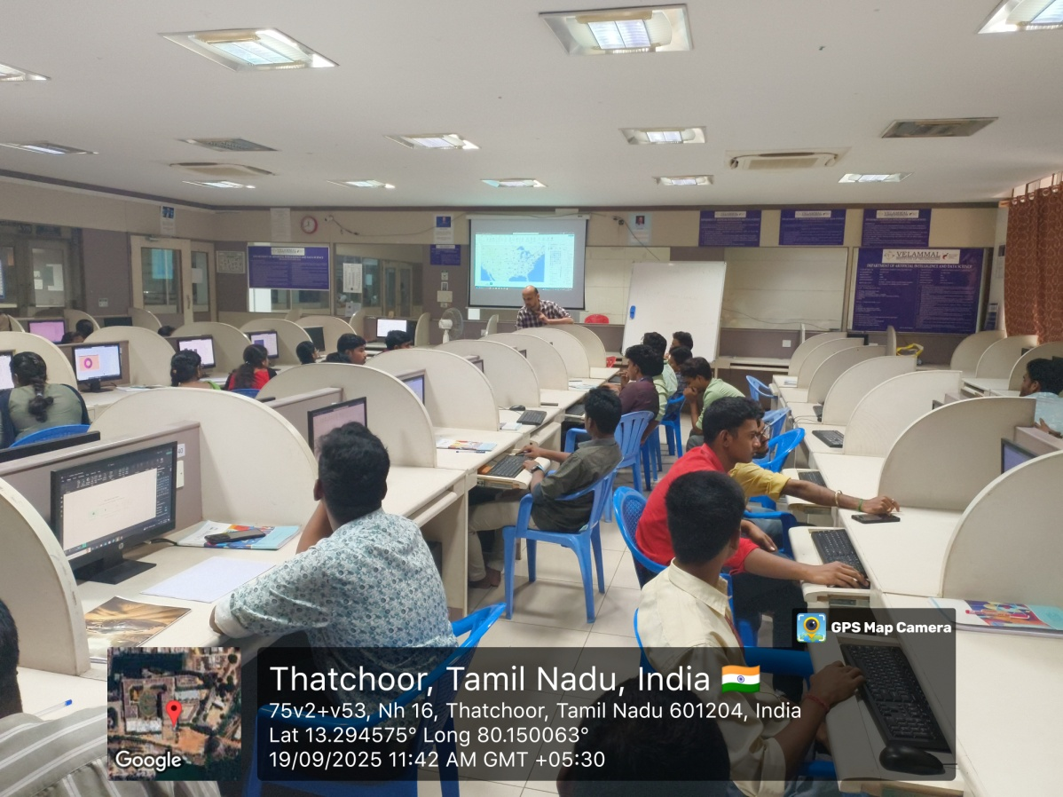
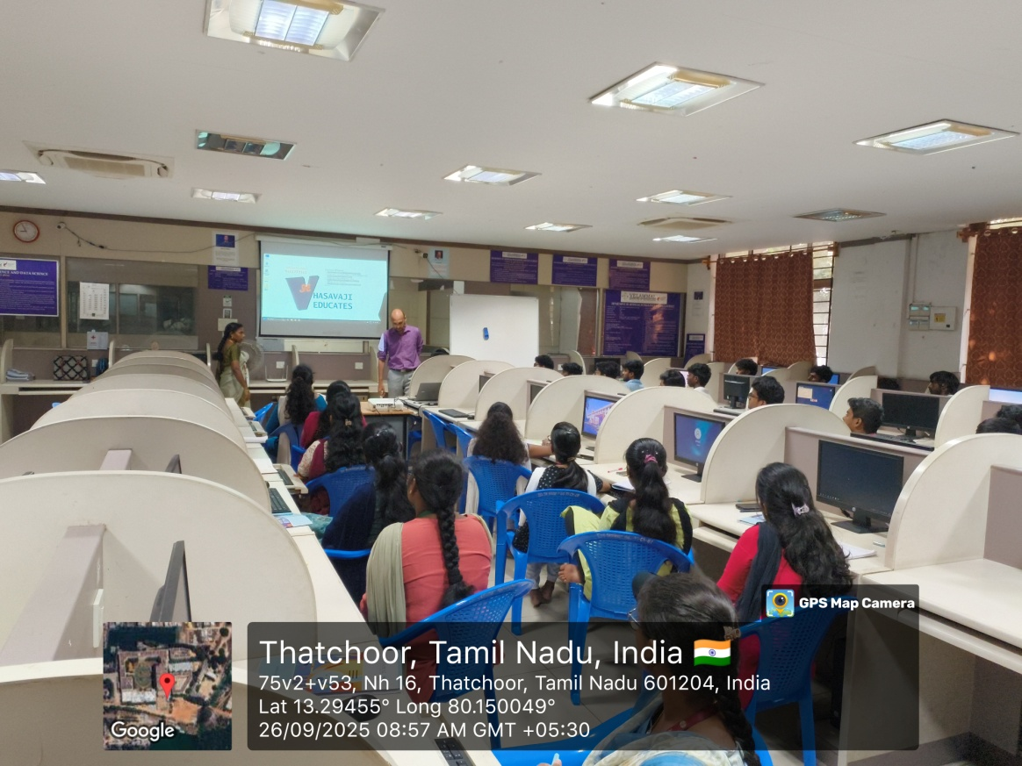
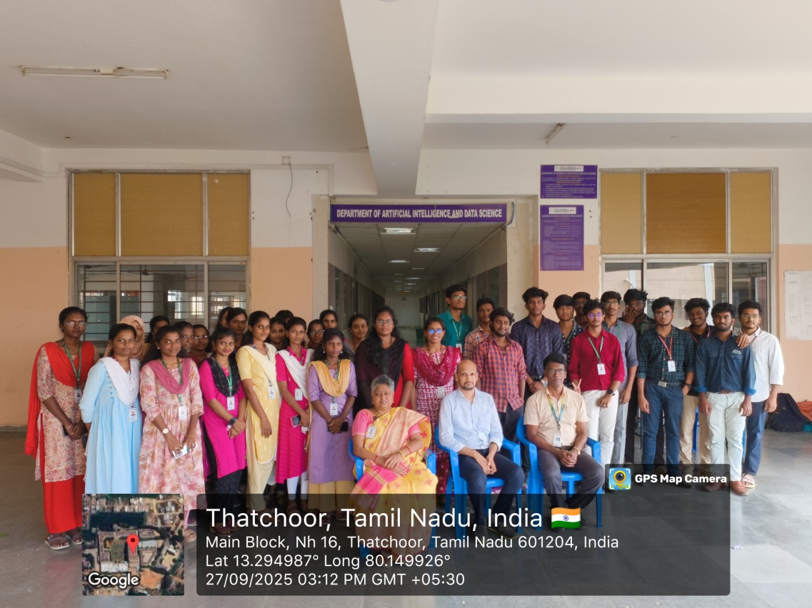
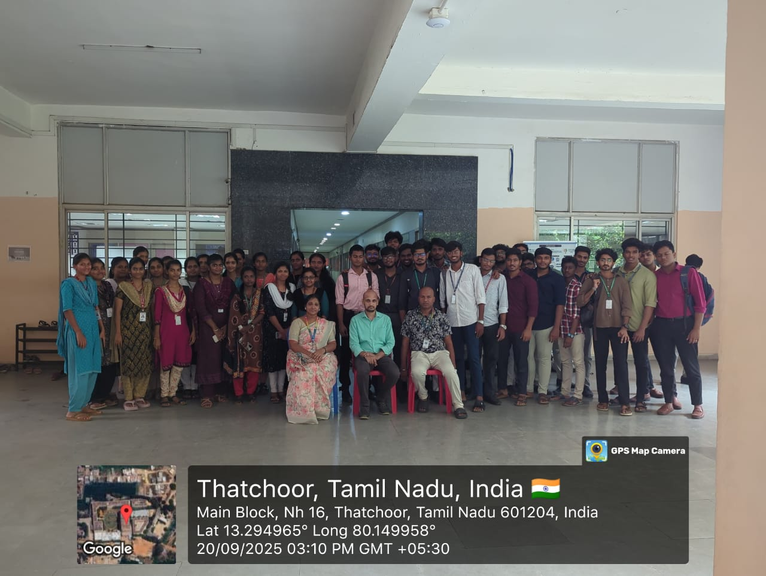
Understanding of Power BI ecosystem. Ability to build basic interactive dashboards. Skills in connecting and transforming data. Insights into report optimization and sharing. Some participants required more time for DAX functions. Suggest a follow-up Advanced Power BI session. Include more real-world datasets for practice
The workshop successfully met its objectives. Participants gained practical experience in building Power BI reports and dashboards. A follow-up advanced session is recommended to deepen analytical capabilities. Overall, the workshop served as a valuable learning experience, laying a strong foundation for students who wish to pursue careers in data-related fields or software development.

Event Coordinator HOD/AI&DS Vice Principal Principal

