Velammal Institute of Technology
Department of AI&DS
Report:Selenium Testing Tool

Program Overview
The two-day training program aimed to equip final year AI&DS students with practical knowledge and hands-on skills in Selenium, a popular tool for automated web application testing. The training blended theoretical concepts, demonstrations, and live project assignments to enable participants to build, execute, and analyze automation scripts.

Day 1: Introduction & Fundamentals
Introduction to software testing and automation, emphasizing the role and advantages of Selenium versus other tools.
Overview of Selenium components (IDE, WebDriver, Grid) and installation procedures.
First practical session: Recording and playing back simple test cases using Selenium IDE.
Demonstration on integrating Selenium WebDriver with Eclipse and writing scripts in Java/Python.
Discussion of locator techniques (XPath, CSS selectors) and practical exercises identifying elements on web pages.

Day 2: Advanced Usage & Project
Hands-on training using Selenium WebDriver for browser automation, form handling, and interaction with dynamic content.
Introduction to TestNG for organizing test cases, parallel execution, and report generation.
Overview of automation frameworks integration: Maven, Jenkins for configuration management and CI/CD.
Mini-project: Teams automated a sample website, executing functional tests and generating test reports.
Q&A and troubleshooting session allowed students to clarify real-world challenges.
Feedback and discussion on career pathways in automation testing and AI-driven testing.

Outcomes
Students gained practical competency in automating tests using Selenium IDE and WebDriver. Enhanced familiarity with writing, executing, and debugging automation scripts in a team setting. Improved understanding of integrating Selenium with automation frameworks and tools.
Participants successfully completed a mini-project, demonstrating test automation for a demo website.

Feedback & Recommendations
Students found hands-on exercises highly valuable, especially script-writing and project collaboration.
Suggestions included extending duration for deeper coverage of TestNG, Jenkins, and advanced troubleshooting.
Enthusiasm for further workshops on AI integration into test automation and exploring other automation tools was noted.

Attachments
Group photo and poster.
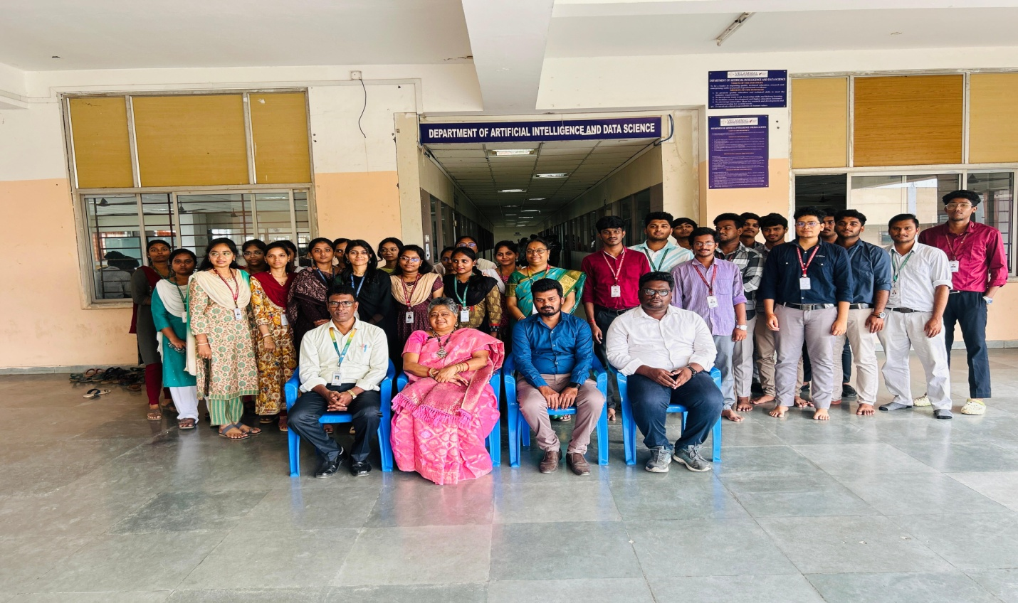

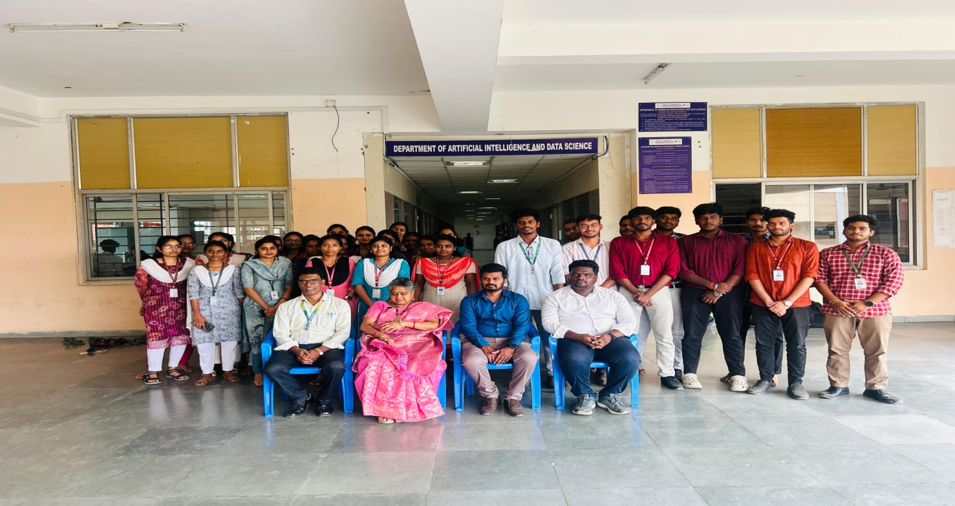
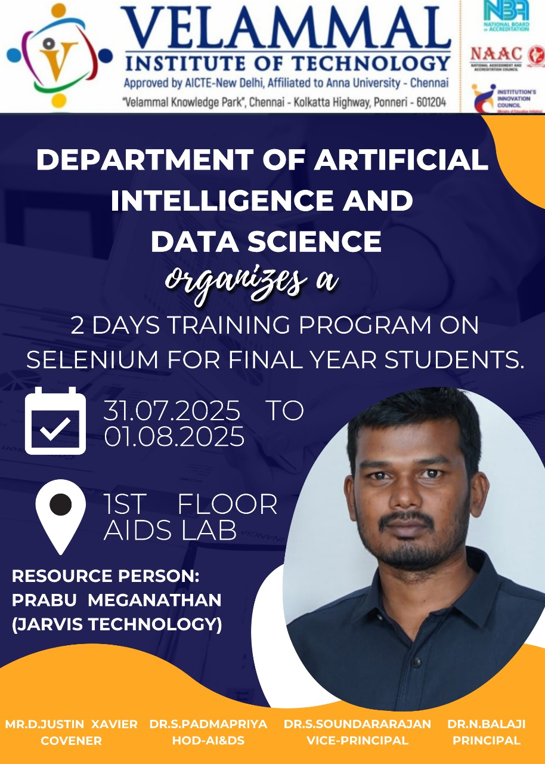

Event Coordinator HOD/AI&DS

