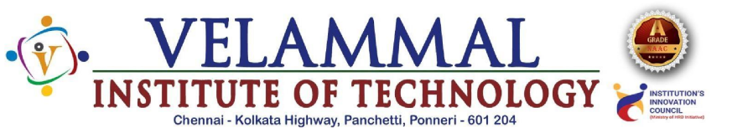
Department of Artificial Intelligence and Data Science
Event Report

Basic Information:
Name of the Event | Workshop
Title | UI & UX Designs
Target Audience | III YEAR A & B Sec
Number of Participants | 119
Event Date | 04/02/2026 & 05/02/2026
Timings | 8.30 am -3.15 pm
venue | AI&DS Lab 2

Objectives of the Event:
This course aims to provide students hands on experience in UI Design Tools,which will be highly beneficial for their academics projects and future career opportunities.

Resource Persons / Chief Guests:
Name & Designation:Mr. Rajkumar Sreenivasan,Founder & Director
Organisation:OVI Design Academy
Event Proceedings:
A comprehensive workshop on UI&UX Design was organized on 04/02/2026 and 05/02/2026 for IIIrd year AI&DS-A&B section students ,the objective of the UI&UX Design workshop to help students understand how to create digital products that are easy to use, attractive, and user-friendly. In today’s technology-driven world, every mobile app, website, and software system requires a good user interface and a smooth user experience. This workshop gives students practical exposure to modern design principles, wireframing, prototyping, and usability concepts, which are essential skills for software development, web design, app development, and product engineering.
Outcomes of the Event:
At the end of the UI & UX Design workshop, students will know how to plan, design, and present a basic user-friendly digital interface. They should be able to identify user needs, create simple personas, and map user journeys before starting the design process. Students will learn how to draw wireframes, develop low-fidelity and high-fidelity prototypes, choose suitable colors, typography, icons, and layouts, and ensure consistency in the design.

Photographs:
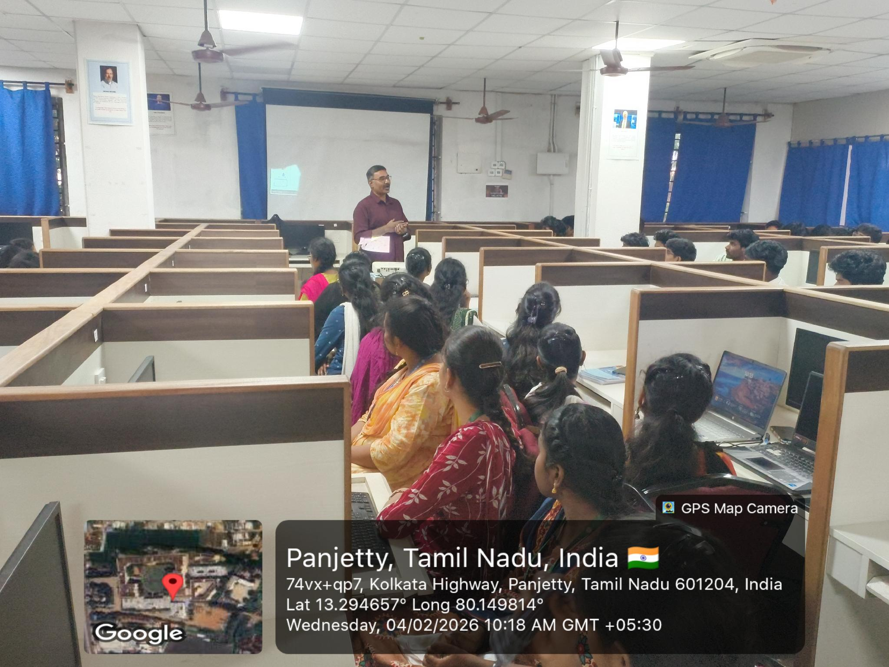

Event Coordinator HOD/AI&DS Vice Principal Principal

