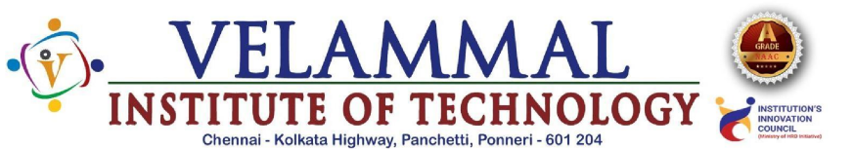
Department of Artificial Intelligence and Data Science
Event Report

Basic Information:
Name of the Event | Workshop
Title | Data Science
Target Audience | II YEAR A & B Sec
Event Date | II YEAR A(05/02/2026 & 06/02/2026)  II YEAR B(06/02/2026 & 06/03/2026)
Number of Participants | 115
Timings | 8.30 am -3.15 pm
venue | AI&DS Lab 1&2

Objectives of the Event:
This course aims to provide students hands on experience in Data Science tools,which will be highly beneficial for their academics projects and future career opportunities.

Resource Persons / Chief Guests:
Name & Designation:Mr. Sanjeev polur
Organisation:Hasavaji Educates

Event Proceedings:
A comprehensive workshop on Data Science was organized on 05/02/2026 and 06/02/2025 for II year AI&DS-A section and 06/02/2026 and 06/03/2026 for II year AI&DS-B section students ,the objective of the Data Science workshop is to provide participants with a strong foundation in the core concepts and practical applications of data science. This Data Science Workshop supported the students in understanding their syllabus in a more practical and application-oriented way.
The topics covered in the session, such as data collection, preprocessing, visualization, statistics, and basic machine learning, directly matched important syllabus units in Data Science, AI, Machine Learning, and Data Analytics subjects. By working with real datasets and tools like Python or Excel, students were able to connect theoretical concepts learned in the classroom with hands-on practice, which made the syllabus easier to understand and remember.
Outcomes of the Event:
By the end of the Data Science Workshop, students gained a clear understanding of the fundamentals of data science and its real-world applications. They learned the complete data science workflow, including data collection, cleaning, preprocessing, analysis, visualization, and basic prediction techniques. Students also received hands-on exposure to tools such as Python, Excel, or Jupyter Notebook for working with datasets. The session helped them understand how to identify patterns, create meaningful charts and visualizations, and apply basic machine learning concepts to solve simple real-life problems.
In addition, they explored concepts such as feature selection, model evaluation, and the importance of data quality in obtaining accurate results. They also understood the role of statistics, probability, and data storytelling in deriving meaningful insights from data. The workshop further enhanced their problem-solving, analytical thinking, and teamwork skills through mini case studies and real-time datasets. Overall, the session enabled them to interpret data effectively, make data-driven decisions, understand ethical use of data, and explore career opportunities in Data Science, AI, and Analytics.

Photographs:
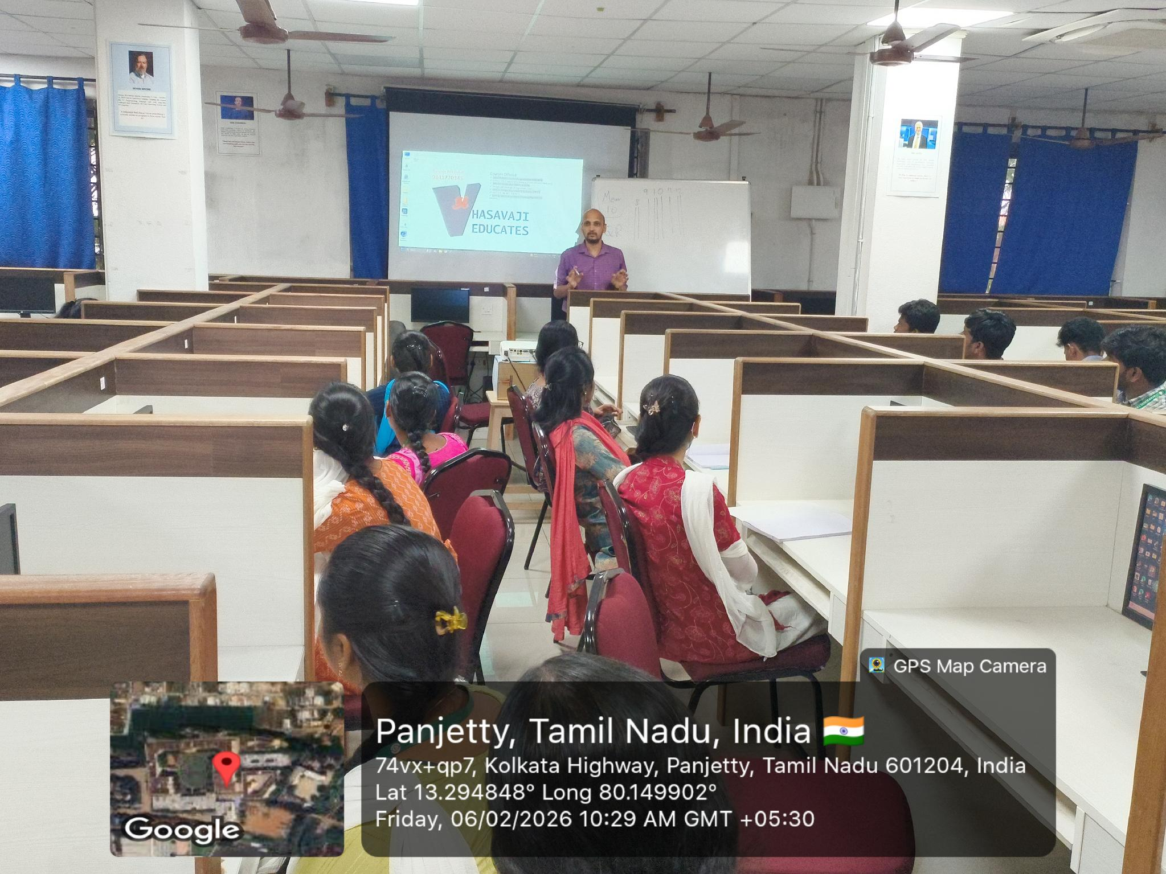
窗体顶端
窗体底端

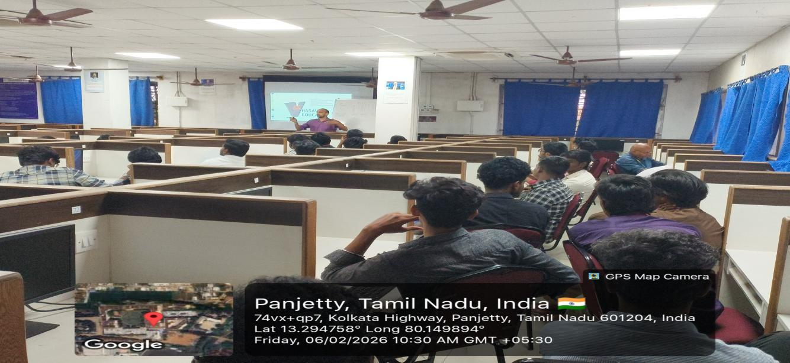

Event Coordinator HOD/AI&DS Vice Principal Principal

