Velammal Institute of Technology
Department of AI&DS
Report:Postgresql Workshop

A comprehensive workshop on **PostgreSQL** was organized on 21/08/2025 and 22/08/2025 for 2nd year AI&DS B-sec students with the objective of introducing them to the basics of relational databases and database management systems. PostgreSQL, a powerful open-source object-relational database system, is known for its robustness, performance, and support for advanced data types. The goal of the workshop was to equip students with both theoretical knowledge and practical skills that are applicable in academic and industry settings.
The workshop began with a brief introduction to databases, covering key concepts such as tables, relationships, primary and foreign keys, and data normalization. Students were then introduced to PostgreSQL, including its history, advantages over other RDBMS tools, and typical use cases in software development.
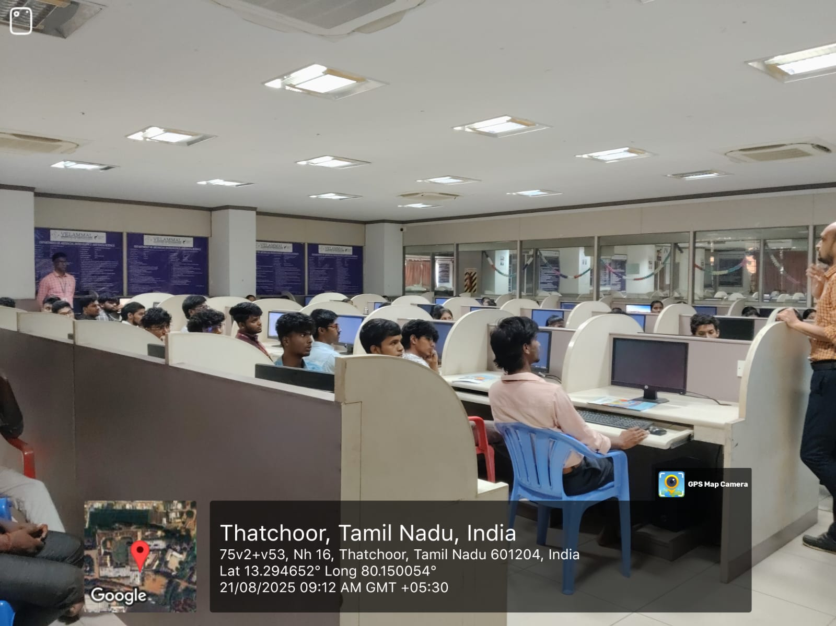
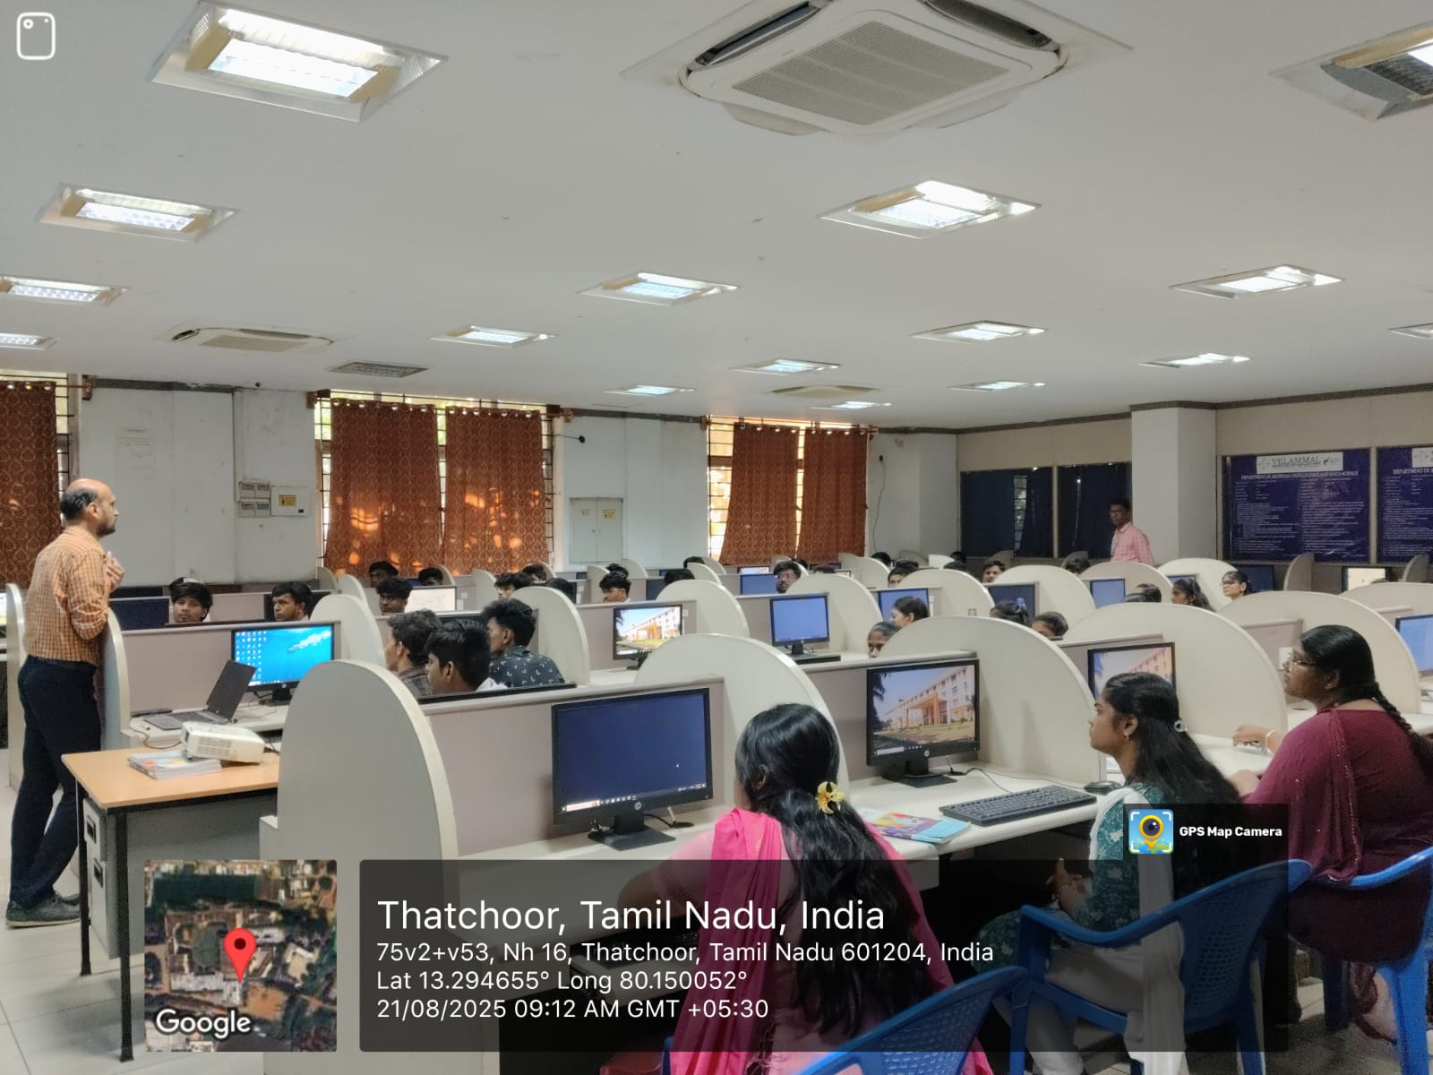
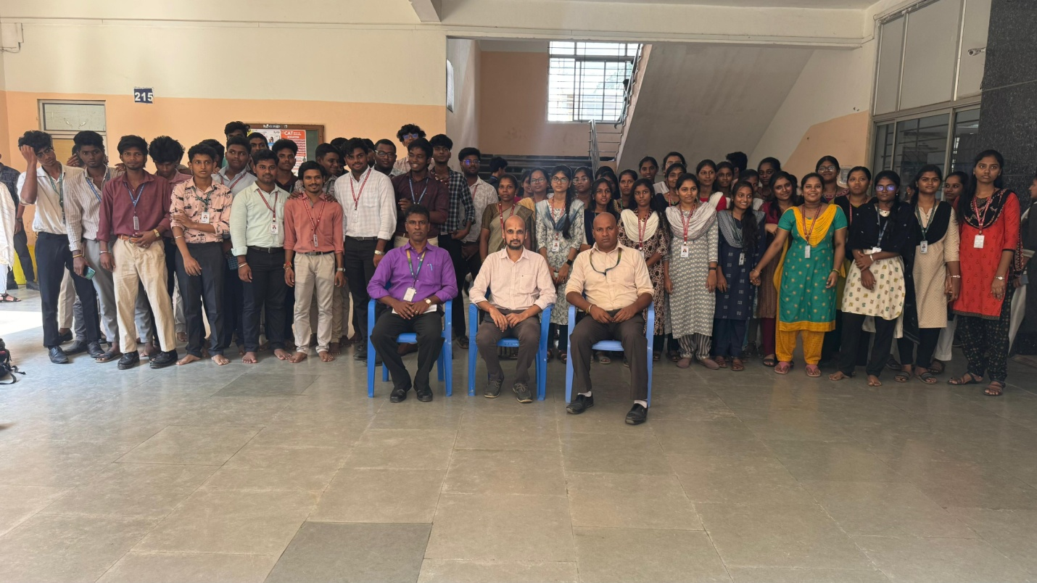
Participants learned how to install and configure PostgreSQL, use **pgAdmin** for graphical interaction, and write SQL queries through the command-line interface. Key topics included creating databases and tables, inserting and retrieving data, updating and deleting records, using constraints, and performing joins. Real-life examples and exercises were provided to help students understand each concept in depth.
Additionally, the session highlighted best practices in database design, such as normalization techniques, indexing strategies for performance, and maintaining data integrity. There was also a Q\&A session where students could clarify their doubts and explore advanced topics like stored procedures, triggers, and database security.
The feedback from students was overwhelmingly positive. Many found the workshop insightful and expressed interest in continuing to learn about PostgreSQL and its applications in backend development, data analysis, and software engineering.
Overall, the workshop served as a valuable learning experience, laying a strong foundation for students who wish to pursue careers in data-related fields or software development.

Event Coordinator HOD/AI&DS

